**MATH STATION #9: I can: Use the computer to look at these bookmarked sites:**

* 
* 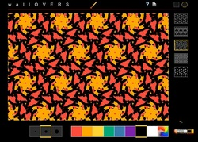
* 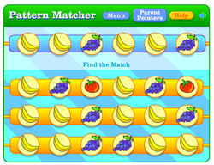
* 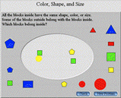 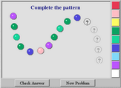 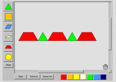

**C:\Users\Christine\AppData\Local\Microsoft\Windows\Temporary Internet Files\Content.IE5\JMQ3AJUF\MC900234134[1].wmf Record my findings and observations (below and on back of this sheet)**

**Name: ____________________________________________________ Date: _________________**